CHECKLIST

Confirm your Eligibility to Apply for USADF-Citi Foundation Pathways to Progress Program funding by checking each item and signing below:
_____ 1. I work in the private or not-for-profit sector.
_____ 2. I do not work for my country’s government, on the national, state, county, or local level (or equivalent).
_____ 3. I am not on leave from a government position, expected to return to public service, nor committed to taking a civil service position after returning to Africa.
_____ 4. My business is located and operating in Uganda, Kenya or Senegal, where I live.
_____ 5. My business is not based on charitable contributions.
_____ 6. I am the founder and/or a principal of my business.
_____ 7. My business is 100% African-owned and -managed, including Board Members.
_____ 8. My business is not engaged in gambling, alcohol, weapons, or other activities that are not conducive to positively impacting society.
_____ 9. My business has a revenue-generating model.
_____ 10. I have completed and am submitting the required application materials, in accordance with USADF’s instructions, documentation, and naming conventions. I am emailing this to Entreprenurship@USADF.gov by 3:00 p.m. ET on Wednesday, November 17, 2021.
Registration:
_____ For existing businesses that are registered:
I have completed the Registration requirement, providing scans of my company’s legal, valid registration for operating, and, as relevant, license(s).
_____ I have included documentation identifying the owners of my organization by name.
_____ OR, for nascent ventures and start-ups:
I have started the process to register my company, documented the steps I have taken (or will take), and included my timeline and the projected date when the identified government regulatory body will authorize or make a decision on my application registration.
Printed Name:
Date:
Signature:
APPPLICATION

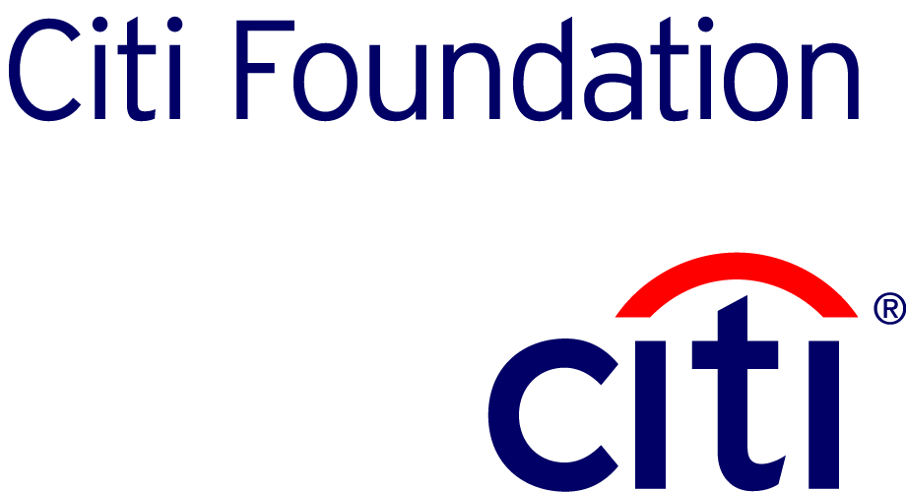

APPLYING FOR AN USADF GRANT IS FREE AND THERE IS NO FEE ASSOCIATED WITH A GRANT APPLICATION

Applicant’s Name:
Applicant’s Country of Residence and Nationality:
Email Address:
Age:
Local Telephone Number:

VENTURE DATA

Venture Name:
Applicant’s Position/Title:
Physical Address of Venture:
Full Mailing Address of Venture:
Sector:  (Please select one category; if your primary sector isn’t listed, please write it beside other) |  |  | Agribusiness ☐  Health ☐  Tech ☐  Finance ☐  Retail ☐  Environmental ☐  Handicrafts ☐  Fashion ☐  Other:
Status of your company:  (Select the definitions below)  - Start-up: You are not selling a product or service. You do not have customers who are paying you for your work. You are not operating your business.  - Early stage: You are selling a product or service. You have customers who are paying you for your work. You are operating your business. You have been doing so for less than 1 year.  - Expansion: You are selling a product or service. You have customers who are paying you for your work. You are operating your business. You have been doing so for more than 1 year. With this grant, you are expanding into a new line of business/new product or service offering. |  |  | Start-up ☐  Early Stage ☐  Expansion ☐
Date of business registration: |  | If NOT yet registered, intended date of registration:
Date of business commencement:

entrepreneur INFORMATION
Text in italics (including this) can be deleted as you complete the USADF Application. Reviewers and Judges will consider no more than 10 pages of this document; additional pages will be discarded, unread.

Suggested: (1) Use font size 11 for your answers, not smaller. (2) Use black font color and standard text – NO italics.
Brief Bio of the entrepreneur applying for grant funding. Please include any relevant experience: (200 words or less). Experience comes in many different forms. Please explain why you are uniquely qualified for this grant. Is this your first venture? How did previous ventures work out and what have you learned from this?

VENTURE INFORMATION
- History: (250 words or less) Why did you begin your enterprise? What has lead you to this point in time? Tell us about successes, revenues, and/or how much has been invested in your company. For start-ups, what have you accomplished? What steps have you taken to launch?

- What are or what will be the primary products and/or services you will provide? (200 words or less)

YOUR Proposal
- Problem: (200 words or less) What is the problem? Where is it located? Who are you reaching? (Be specific, such as the # of farmers (name your country, state and/or county) NOT the 5 million people in your country with a plot of land). How many people will you impact directly? Be realistic; this is a 1-year grant term.

- Solution: (200 words or less) What is your solution? How are you tackling the problem? What are you going to do about it? What is innovative about your approach? What impact do you hope to achieve for the wider community that the proposed project grant will contribute to? What is your goal on a macro-level?

- Expected Outcomes: (200 words or less). Bulleted answers are preferred. What calculable results will the project achieve for the target customers, suppliers, and/or other beneficiaries? How will you measure success? Provide at least 2 tangible measures that you can count.

- 6 Month Work Plan: Please provide a workplan for a month-by-month plan for the next 6 months for your business. What do you need to do in the next 6 months to ensure your business is best suited for success?
VENTURE DETAILS
- Employees and Beneficiaries

Please fill out the section below as it currently relates to your venture. Only count your current employees and beneficiaries, not your intended numbers.

Employees
Number of paid Employees | Male |  | Female |  | TOTAL:
Number of non-paid employees | Male |  | Female |  | TOTAL:

Customers (to date, if start up, write N/A)
Number of Customers or Beneficiaries | Male |  | Female |  | TOTAL
Target Customer (check all that apply): | Rural ☐ Urban ☐ Peri-Urban ☐

B. OWNERSHIP STRUCTURE: If there are multiple owners, please include their name and title below, as well as their relative stake in the organization.
Name | Citizenship | Title

C. CURRENT FINANCIAL SITUATION

1. List the major assets owned by the venture and the corresponding value if known (such as money in the bank, credit owed by buyers, equipment, building, land, etc.).
Asset Type | Value

2. List any loans (amounts, term, provider) and other liabilities attached to the organization?
Loan Type | Value | Balance Due

3. List all sources, amounts, and dates of any donor, government, or other outside funding received. Have you requested any other funding (grants or loans) support from other donors, NGOs, government, private companies, or banks that are still being considered? If yes, please list details (Name of donor, date of decision, type, amount). This will not disqualify any applicant.
Donor Name | Date | Type (Loan / Grant) | Value

BUDGET TABLE

Category | Description | Cost ($)
- Infrastructure
A1.
- Equipment purchases
B1.
- Raw materials/ inputs
C1.
- Training (including conferences)
D1.
- Technical assistance
E1.
- Administrative support
F1.
TOTAL not to exceed $US10,000

Budget Narrative: Describe items in each category you use; you may add lines for additional items, i.e. C1, C2, etc. You may remove lines you do not use, i.e. E1, F1, but do retain all categories, even if you do not request funds in certain categories.

Confidentiality Statement:
USADF treats all submissions with respect and discretion. If you feel that significant confidentiality issues will arise in the course of preparing your plan, you should have a thorough understanding worked out with your venture’s leadership team in advance. While every effort will be made to preserve the confidentiality of each submission, it is suggested that highly sensitive material be excluded from the entry if you are concerned about the confidentiality of such material.

The only individuals who will have access to the materials you submit (in addition to USADF staff and reviewers) will be the outside judges assigned to review your business plan application. These judges regularly deal with confidential information in the course of their work. They sign a non-disclosure agreement, and we ask them to treat your work product with the same care and respect for confidentiality they use in their daily work. We also ask them to remove themselves from judging your plan if they have a real conflict of interest. Feel free to mark your materials as "confidential." Note that the short description of your venture which you include with your application may be used in public documentation relating to the competition, should your venture be selected for USADF grant funding.

